Task Objective:
Implement the travel notifier application that notifies the user in Slack, and how much time and KM it will take if the user enters the source (Where he is at this time) and the destination (Where he wants to go) and when the results are sent to the user's Slack, the data will be saved in the database (SQlite3) for future consideration and usage. We will use the Google Routes API.

Application Structure:
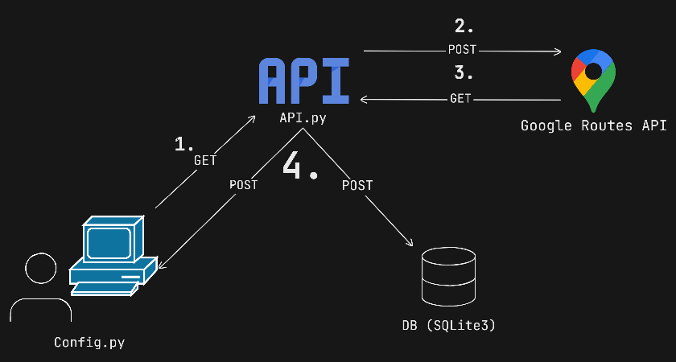

- Submitting the form (config.py)
- The inputs are fetched from the (config.py) file to the API. #GET from config.py
- API sends the data to Google Routes API. #POST to Google Routes API
- Get data from the Google Routes API. #GET from Google Routes API
- The API sends the fetched data to the database and to the user (Slack). #POST to DB & User

System Workflow Summary:
- User Input Configuration
- The user provides the source and destination locations inside config.py.
- These values serve as the primary input for the travel-time computation workflow.

- Google Routes API Integration (main.py)
  - main.py reads the source and destination from config.py.
  - The system sends a request to the Google Routes API, using the default travel mode: DRIVE.
  - Traffic-aware routing is automatically applied to calculate accurate travel duration and distance.
  - The API response (distance in meters and duration in seconds) is processed and converted into user-friendly units (km and minutes).

- Result Synchronization Back to Configuration
- The computed travel distance and duration are passed back to logic aligned with config.py, enabling centralized access to all important results.

- Database Logging
- The processed travel data (source, destination, distance, and duration) is stored in the application’s database for record-keeping and historical usage.

- Slack Notification Delivery
- A formatted message containing the travel summary is automatically sent to the user's designated Slack channel.
- The notification includes:
  - Source and destination
  - Travel distance (km)
  - Estimated duration (minutes)
  - Real-time traffic consideration
- Slack Webhook is used for seamless, direct message delivery.

